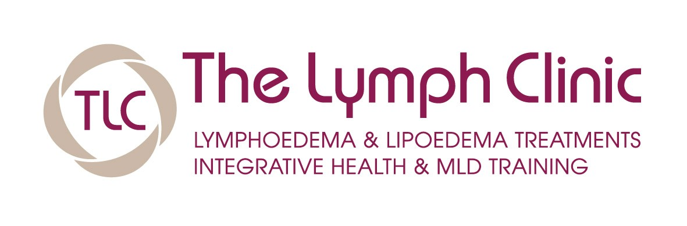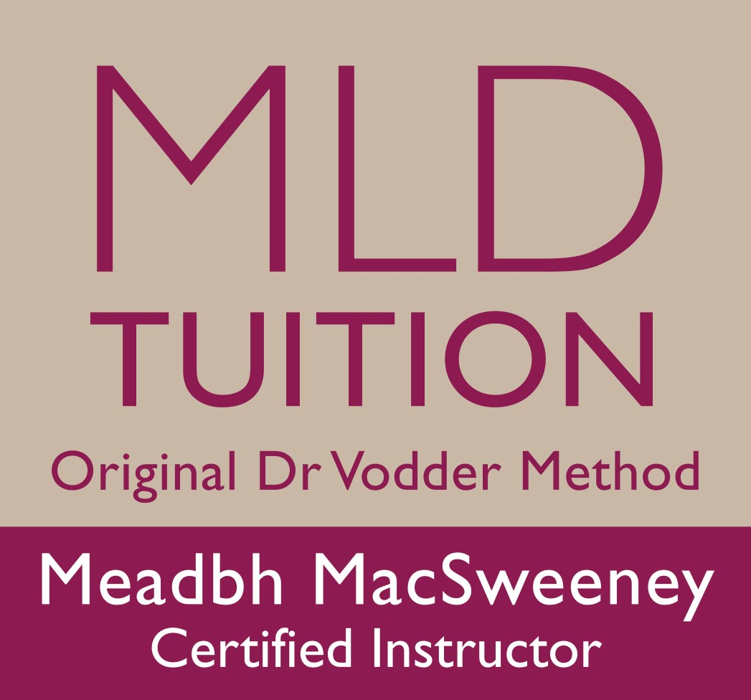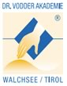

Certified Training and Tuition in Manual Lymphatic Drainage (MLD) Dr Vodder Origional method.

SPRING BOOKING FORM BASIC & THERAPY 1 2017
Please complete in full

Name ……………………………………………………………………………………………

Address ………………………………………………………………………………………………...

………………………………………………………………………………………………...

Telephone :

(Home) ……………………………….. …………

(Work) ……………………………………………..

(Mobile)……………………………………………….

Email: ………………………………………………………..

Profession: ……………………………………………………………..

Basic

FRIDAY March 17TH TO TUESDAY March 21st

Therapy 1

FRIDAY April 21st TO TUESDAY April 25th

Total cost for both courses € 1,700 ( includes all course material)
The balance of course fee must be paid 2 weeks prior to course commencement

NB: PLEASE FORWARD WITH BOOKING FORM:

- Cheque should be crossed and made payable to MLD Tuition

- OR evidence of electronic payment:
Direct / online deposit to A/C mldtuition AIB Western Road Cork,
A/c MLD Tuition , no : 24172039 S/c 934194
BIC :AIBKIE2D IBAN:IE 48 AIBK93419424172039

NNB: Please include your name on Narrative and email to confirm payment

I enclose copies of relevant qualifications Yes

I enclose a non refundable deposit of €300 YES

My polo shirt size : SMALL / MEDIUM / LARGE / XLARGE

Signed: ………………………………………………………………………

Date: …………………………

Please return

1 .Completed form,
2. Qualification photocopies and
3.Cheque made payable to MLD Tuition or

to : Meadbh Mac Sweeney, The Lymph Clinic , Suite 1 , Cork Clinic,
Western Road , Cork

Tel : 021 4347351 or 086 8048273 ,

Web: www.thelymphclinic.ie

EMAIL: meadbh@thelymphclinic.ie

