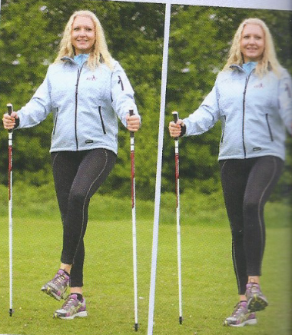
Mobilize ankle Joint
Stand with feet shoulder width apart, lift one foot from the floor and circle in one direction & then the other. Flex and Point Foot.
Repeat other foot.
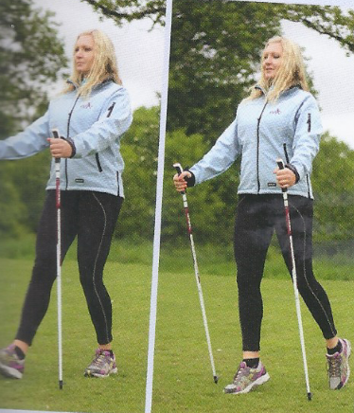
Prepare calves, shins and ankles
Maintain upright body position and abdominals engaged. Rock back & forth from heel to toe.
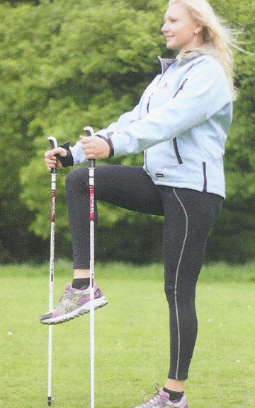
Mobilize hips and warm up thighs
Use poles for support, lift the knees alternatively marching on the spot. Lift only as high as is comfortable.
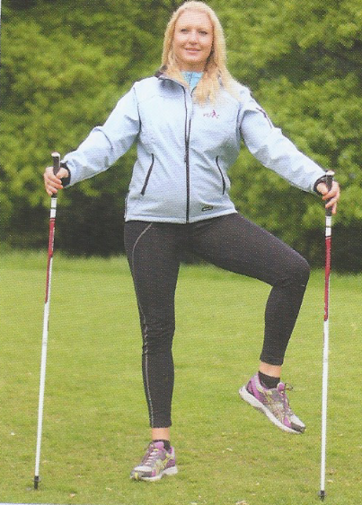
Mobilize the hips & warm up inner thighs.
Lift the knee to the front, circle to the outside and then return the foot to the ground. Repeat other side.

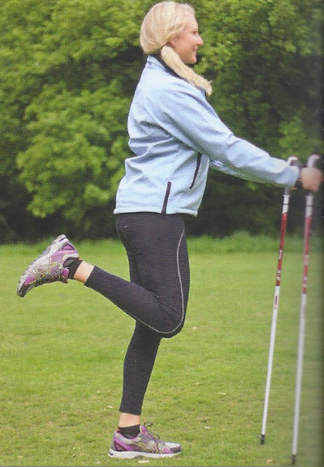
Warm up buttock & Hamstrings
Lift feet alternatively towards the buttocks. Keep knee still as you lift the lower leg so both knees remain in line.
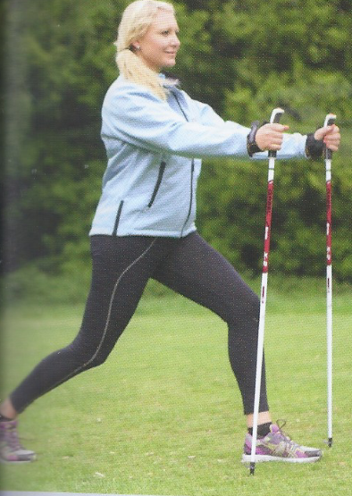
Step Lunge – Mobilize hips and knees and to warm up buttocks, thighs and calves.
Step forward, initially keep lunge shallow until you warm up. Always remain within your comfort zone.
Warm up back, hips, buttocks, thighs and calves.
Ensure that the knees do not travel further than the toes. Bend at the knees and sit back to a dept that is comfortable.

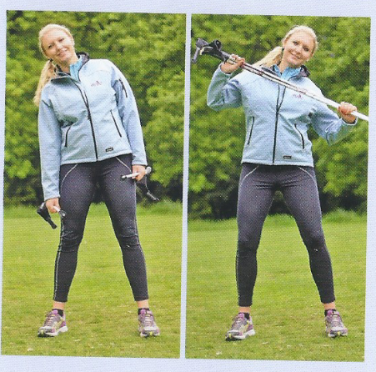
To warm up side abdominals and back muscles.
Keep the knees soft and pelvis still. Hold the poles as shown and bend gently from side to side without learning forwards or back. To progress hold poles across chest.

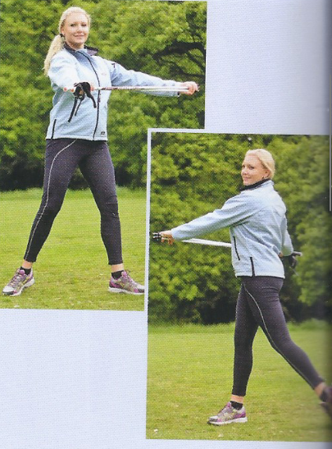
To mobilize the spine and warm up back muscles.
Hold your pole in front of your body with arms horizontal. Rotate gently from side to side within your comfort zone.
Start with feet planted on the ground but you may feel you want to progress by shifting weight from foot to foot in direction of rotation.

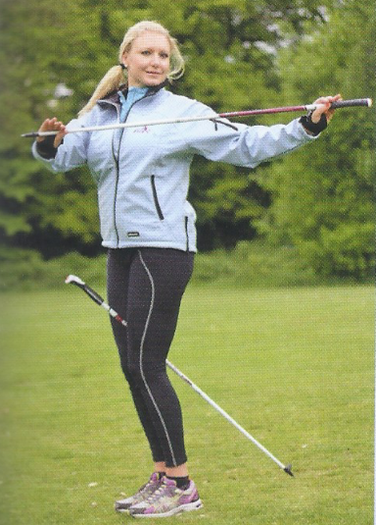
Mobilise the spine muscles
To enhance the spinal rotation and ensure pelvis does not move. Try placing pole between thighs with the pole tip touching the ground behind. If pelvis moves the pole presses the inner thigh indicating the abdominals need to maintain better control.

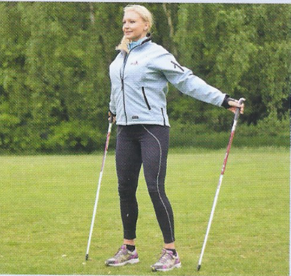
Chest Opener
Place the poles to the side of the feet and gently drop the hands to the side.
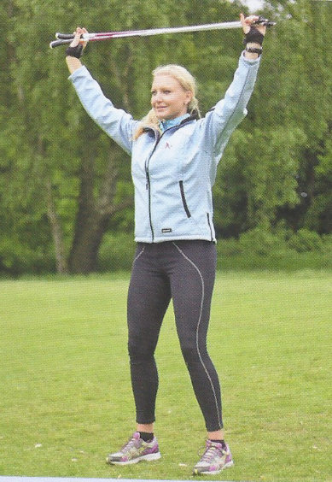
Shoulder Press
Mobilise the shoulders
Simply hold the pole horizontally and press them upwards from the collarbone to above the head and repeat.
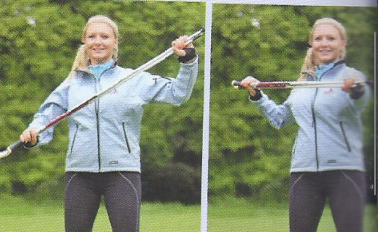
Pole Kayak
Warm up muscles in the shoulders, arms, back and side abdominals.
Hold the poles horizontally across your body, punch one hand out in front of your face whilst pullin

